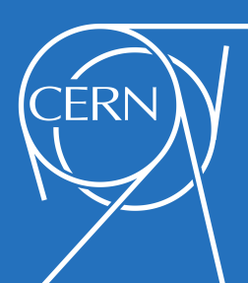
Easter CERN Visit
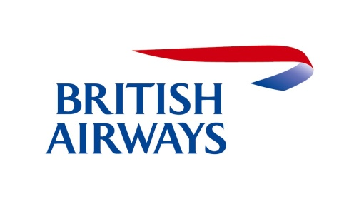
Programme of Events

Day One: Tuesday 23rd April 2019
Depart Merthyr College for London – Heathrow Airport. (New Adventure travel).
Flight departs Heathrow.
Arrive at Geneva airport, Switzerland.
Use the free local transport into Geneva city centre.
Check out the hotel Montana www.hotelmontanageneva.com/

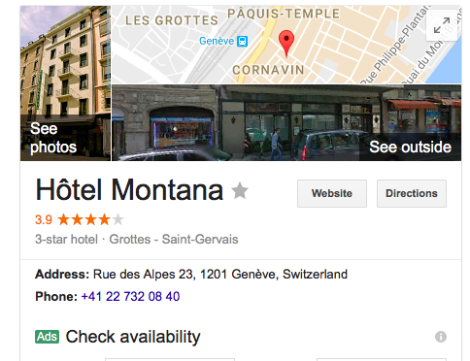
Free Wifi.
- Located centrally in Geneva City Centre.
- Close to the tram line which leads to the CERN facility.
Once checked in pupils will be able to walk around Geneva City or the Geneva lakes.
7.00 pm: Dinner at Restaurant Edelweiss – a traditional swiss restaurant with live music.

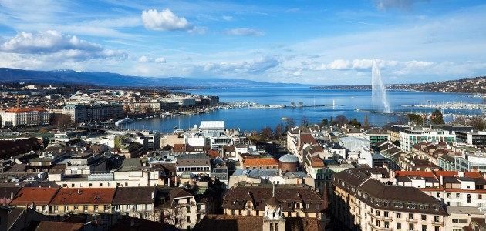
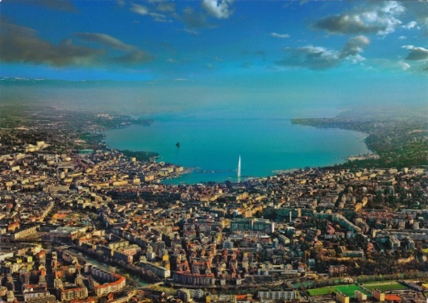

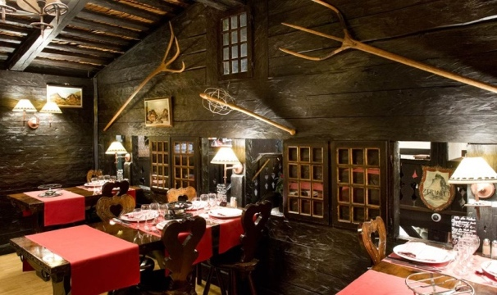
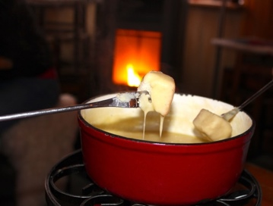
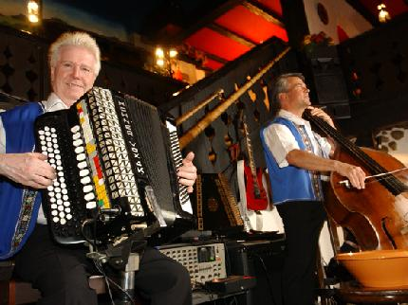
Day Two: Wednesday 24th ^{th} April 2019
8.00 am: Breakfast at the hotel.
9.00 am: Bus picks us up for the Chamonix excursion.
11.00 am: Arrive at Chamonix.
During the day at Chamonix pupils will be able to catch the mountain railway to the Aiguille du Midi, which is a 3842m peak of Mont -Blanc.
The braver pupils could take the cable car instead, which holds the world record for the highest vertical ascent.
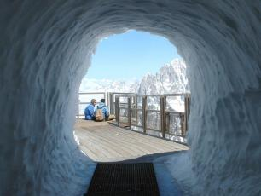
At the Aiguille du Midi peak, pupils can eat in the North Tower Restaurant which is one of the highest restaurants in the World! There are also many viewing areas that overlook the spectacular French Alps.
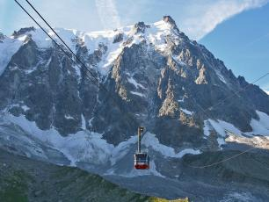
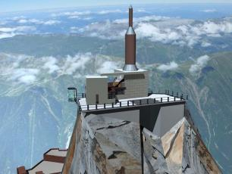

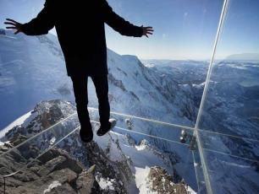
Whilst at the Aiguille du Midi peak you can also ‘Step into the Void’ which is a glass room with a glass floor situated over the edge of the peak. This is not for the faint hearted!
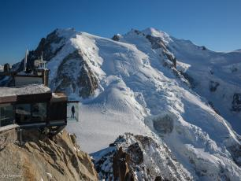
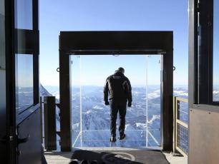
In the afternoon, you could then take the train of the Montenvers down to the Mer de Glace (Sea of ice) and the Ice Cave.
At 7km long and 200m deep it is the largest glacier in France.
The Ice Cave is man-made and is dug out of the side of the glacier. This must be done every summer as the glacier moves about 70m per year.
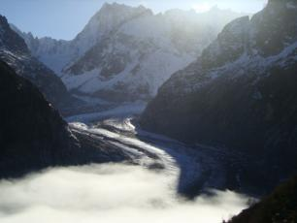
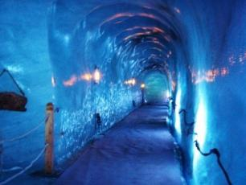
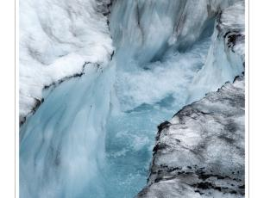
The cost of the multi-pass is 64 CHF and will cover access to the Aiguille du Midi, the cable car and the Montenvers down to the Mer de Glace. Pupils will need to purchase this pass on the day.
5.00 pm: Depart Chamonix.
7.00 pm: Arrive back at hotel.
9.00pm: Dinner

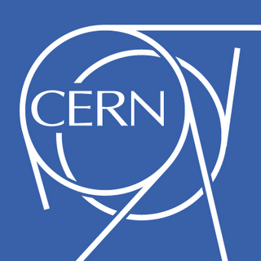
Day 3: Thursday 25th April 2019
7.00 am: Breakfast at the hotel.
8.00 am: Take the tram to the CERN facility.
9.00 am: Meet visits manager at CERN.
CERN is the European Organization for Nuclear Research and is one of the most exciting places in the world to work for a physicist or engineer.
Founded in 1954, CERN has now over 21 member states and has an extensive international education programme.
At CERN pupils will be given a guided tour around some of the main attractions of the facility and will be given a presentation on particle physics by one of CERN’s top scientists.
The programme for the day will not be provided to us until 1 month before the visit but below are some of the things that may be included.
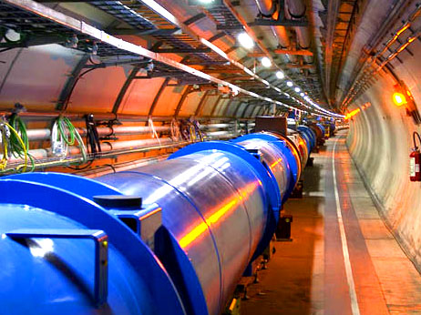
The Large Hadron Collider (LHC) is the world’s largest and most powerful particle accelerator. It is a 27km ring of superconducting magnets. Inside the accelerator, two beams of particles, travelling at close to the speed of light, are made to collide. The collisions, have helped discover tiny particles, such as the famous Higgs Boson and has helped develop our knowledge of matter and antimatter.
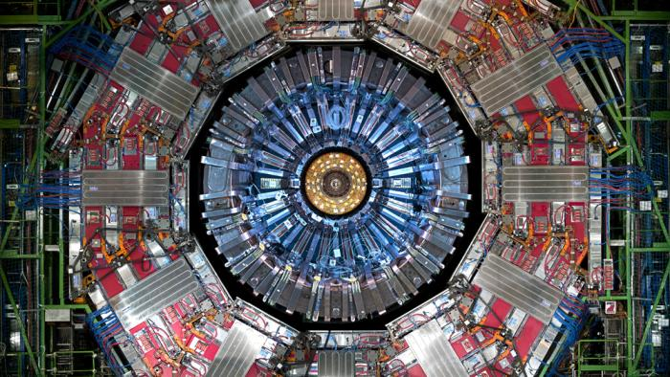
The CMS detector uses a huge solenoid magnet to bend the paths of particles so they can be identified after collisions in the Hadron Collider.
The ATLAS is another detector of the LHC which has been used to investigate dark matter.
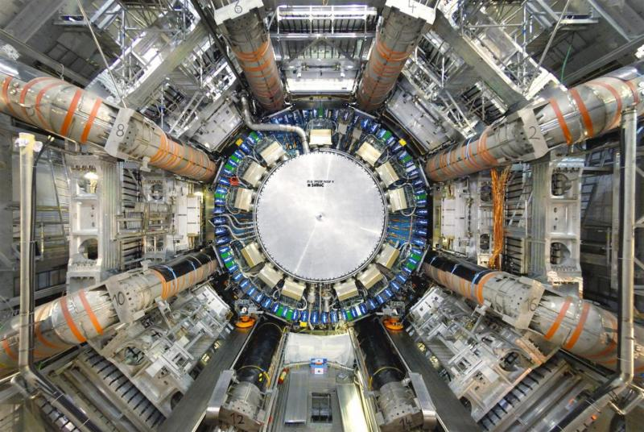
The Antimatter Factory is where antimatter is studied. Super cool liquid helium is used to look at the properties of antihydrogen and whether there is such a thing as antigravity.
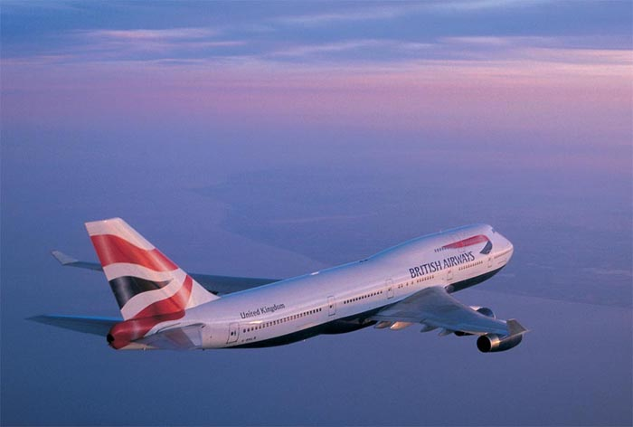
7.00 pm: Dinner
Day 4: Friday 26th April 2016
9.00 am: Breakfast at the hotel.
10.30 am: Tram to the airport.
Flight departs Geneva.
Arrive at Heathrow airport.
Arrive at Merthyr College.

Other Information:
Currency: The local currency is the Swiss Franc (CHF)
The exchange rate is 1GBP = 1.47CHF (16th Oct 2015)
Time Difference: Geneva is 1 hour ahead of the UK.
Temperature: The average temperature in Geneva in April is 9.1ºC.
In Chamonix this will be a lot lower so extra clothing will be required for that day.
Additional Costs: Apart from breakfast all other meals will need to be paid for as and when we have them.
Local transport is free if pupils collect a tram pass at the airport.
The multi-pass in Chamonix is roughly 64 CHF (Oct 2015) but this could change for next year.
